***VPC WITH PUBLIC-PRIVATE SUBNET IN PRODUCTION***

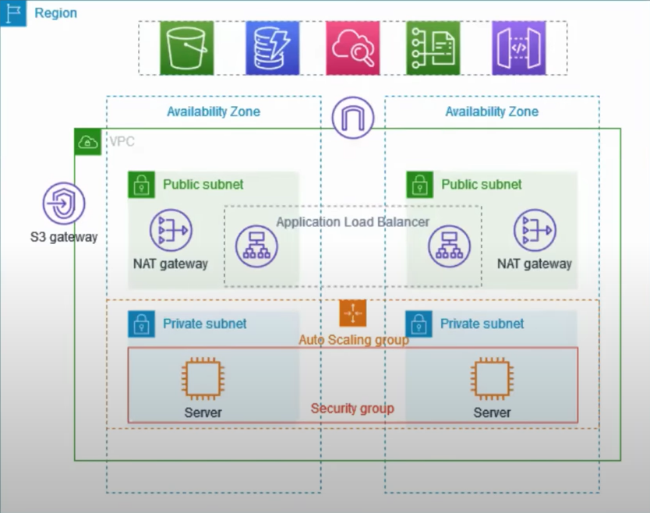

**About the Project :**

This example demonstrates how to create a VPC that you can use for servers in a

production environment.

To improve resiliency, you deploy the servers in two Availability Zones, by using

an Auto Scaling group and an Application Load Balancer. For additional security,

you deploy the servers in private subnets. The servers receive requests through

the load balancer. The servers can connect to the internet by using a NAT

gateway. To improve resiliency, you deploy the NAT gateway in both Availability

Zones.

**Overview :**

The VPC has public subnets and private subnets in two Availability Zones.Each public subnet contains a NAT gateway and a load balancer node.The servers run in the private subnets, are launched and terminated by using an Auto Scaling group, and receive traffic from the load balancer.The servers can connect to the internet by using the NAT gateway.

**SOME SNAP SHOTS:**

**VPC**

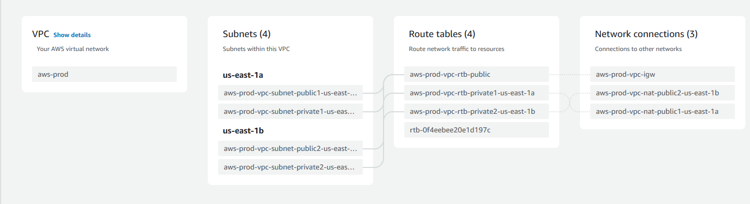

**EC2**

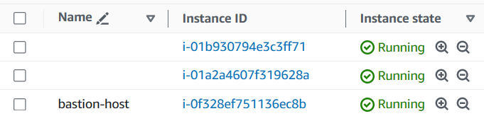

**LOAD BALANCER**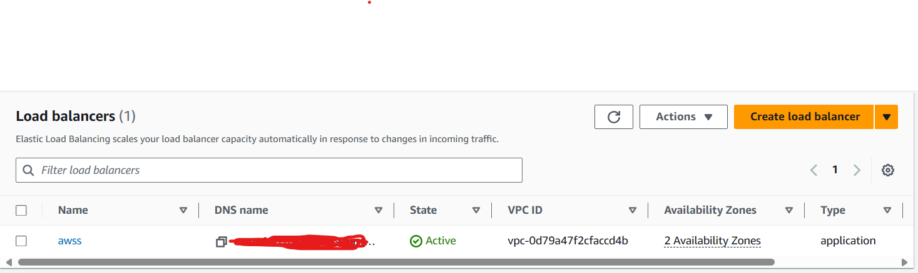

**AUTO SCALING GROUPS**

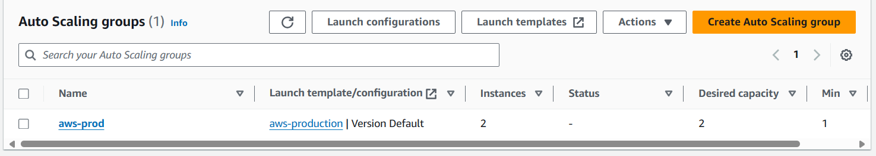

**APPLICATION :**

